**JAVASCRIPT DEVELOPER PROFILE**

**EXERCISE FOR TECHNICAL SKILLS EVALUATION**

**Scope of the Exercise**

We ask you to read carefully this use case, and develop all possible functionalities in coherence with the requests within the assigned time. We will evaluate how you will be able to deliver in a short time, with poor info, as much as possible meeting the Client expectations. This is unfortunately the usual situation that we can encounter. The due date has been shared in the assignment email.

**Test duration:** 3 days from the date the task is received.

**Technical requirements:** Back end library: Nodejs; Front end Library: Reactjs

**Test solution:** Test solution must be sent as a Github URL.

Send us your task solution or any questions (do not hesitate to ask) you may have to: [hr@itvaluepartner.eu](mailto:hr@itvaluepartner.eu); [ashok.yarramneni@itvaluepartner.eu](mailto:ashok.yarramneni@itvaluepartner.eu);

**Disclaimer:** The only purpose of this task is to assess candidate skills. Everything sent as a result of the task will not be used for commercial purposes.

**Use Case and business requirements**

We want to develop a single page web application which has the main scope of importing some data through a csv file (“account_statement.csv”) and consolidate some calculations to update relevant information.

**The scope of our application is to import the transactions related to income, expenses and purchases linked with two different bank accounts. These transactions are defined in Euro and US dollars and therefore the relevant balances need to be updated by the currency of each transaction.**

The two bank accounts (Conto), where the 1612660 can be considered has the main account, have different types of transactions (Tipo) in EUR and USD and in particular:

* Versamento: is the transfer into the account of a sum of cash
* Prelievo: is the withdrawal of a sum of cash out of the account
* Acquisto: is the purchase of services/good or expenses
* Vendita: is the sale of services/good or incomes

All the transactions are reported in the file with absolute values but the software needs to correctly import, on the back end, and manage the values with the proper sign, in order to calculate and update the balances in EUR and in USD.

The cash balance for each account and for each currency (Divisa) is given by the Total counter value credited or debited at transaction level.

The Total Counter value is given by the Net countervalue (Importo Netto = Prezzo*Quantità) with the consideration of Taxes and Commissions; and is calculated with the following formula:

*If Tipo is equal Versamento or Vendita then Total counter value (Importo Lordo) need to be calculated as Price*Quantity and subtracting the values of eventual Taxes (Imposte) and Commision (Commissioni). The result has to credit the account balance.*

*Otherwise*

*If Tipo is equal Prelievo or Acquisto then Total Counter value (Importo Lordo) need to be calculated as Price*Quantity and adding the values of eventual Taxes (Imposte) and Commissions (Commissioni). The result has to debit the account balance.*

(Attention: take care on how to define/manage the signs of the counter values, taxes and commissions, to have the correct effect on the Total Counter value).

On Front end side it is necessary to develop one page where the accounts balance, for each account distinguished by currency, is presented within a report that can query these balances by date (Data), type of transaction (Tipo) and channel (Circuito di pagamento). To define the layout please refer to the image below and check the prototype on Figma at the following link:

<https://www.figma.com/file/wZ95XJdQCID6j1jdb9Gkco/Untitled?node-id=0%3A1>

**Uploading page**



**Results Page**

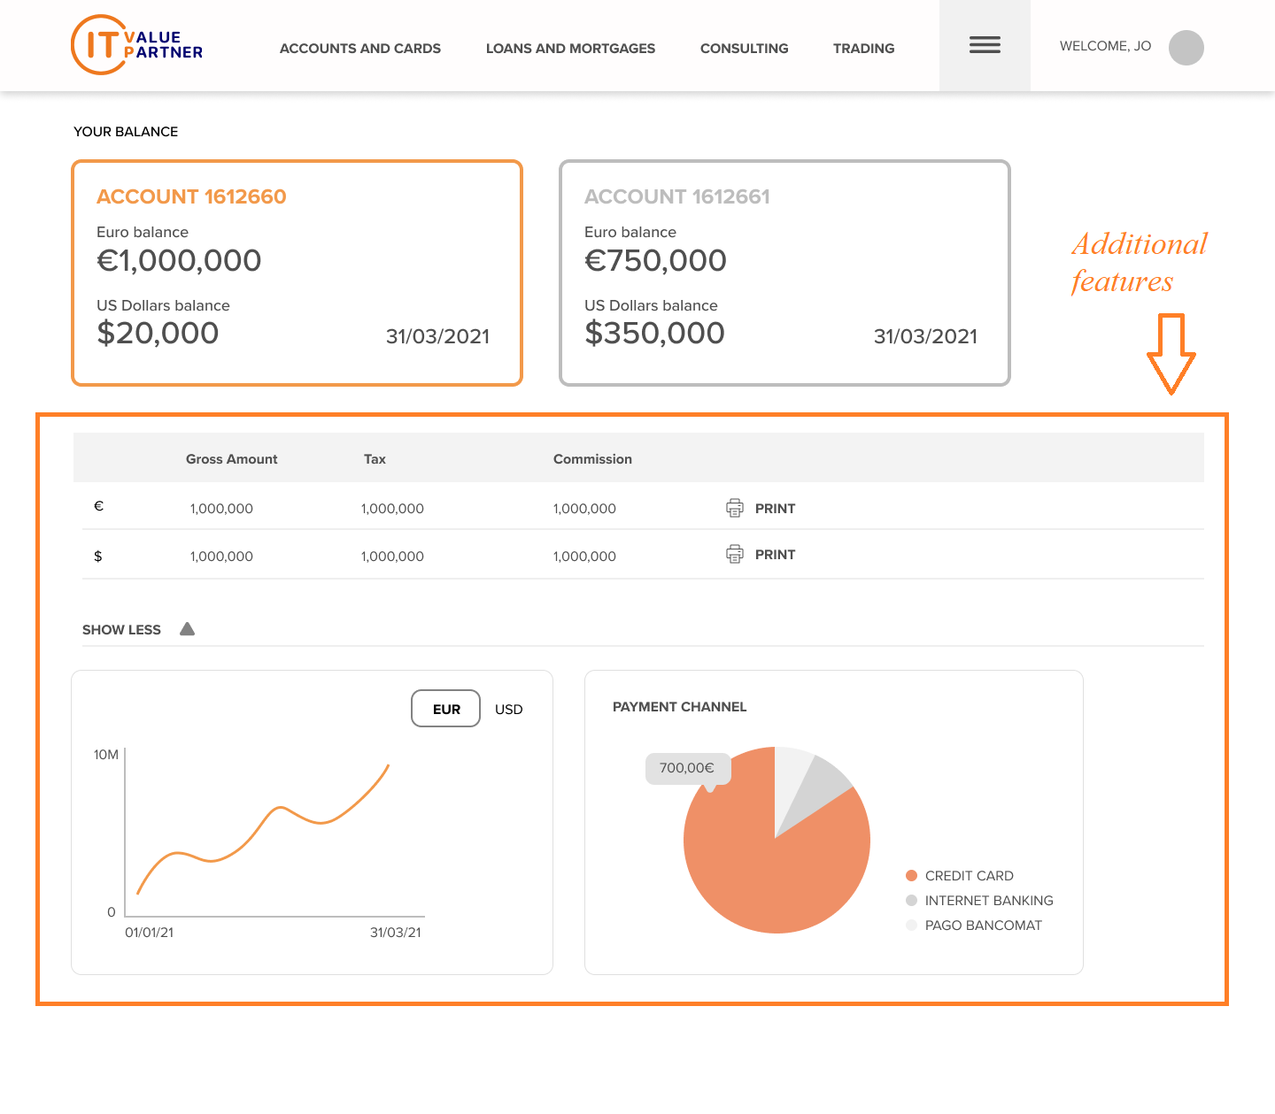

**Software Logical Architecture**

The application should

* Import a csv file
* Import the data of the transactions (and store in JSON or DB)
* Calculate the correct amount of EUR and USD for the two accounts
* Report the result on a web page

**Additional features**

If there is the time and the possibilities these additional features should be developed:

* Differentiate the cash balances segregating Net counter value, Taxes and Commissions in addition to the Total counter value
* Define some metric Analytics using the other data available on transaction level aggregating form example by
* Present in addition to the cash balances (EUR and USD) also the securities balances by account aggregating the net amount (Importo Netto) by ISIN with length greater than 3 digits. Attention take care on the sign of the quantity in case of Acquisto (quantity need to be sum) or Vendita (quantity need to be subtracted).
* Convert the balances in USD in EUR using the rate from an external service provided by Banca d’Italia. The rate to be used is the one with referenceDate= ‘31/03/2021’; baseCurrencyIsoCode =‘USD’; currencyIsoCode=’EUR’. Please refer to the technical documentation “Operating_Instructions.pdf”